BUG IDENTIFICATION REPORT

BUG-001: Gender Dropdown Field Accepts Invalid Random Characters
Bug ID: BUG-001
Summary: Gender field accepts any text input instead of restricting to dropdown values
Severity: High
Priority: High
Status: Open
Bug Type: Functional - Data Validation
Bug Category: Security, Data Integrity
Environment:
- Browser: Google Chrome/ Firefox
- OS: Windows 11
- URL: https://buggy.justtestit.org/profile
Description: The Gender field in the user profile "Additional Info" section is implemented as a dropdown but lacks proper validation. Users can manually type and enter random characters, numbers, or any arbitrary text instead of being restricted to predefined gender options. The system accepts and saves this invalid data without any error message or validation.
Steps to Reproduce:
- Login to application with credentials: Username: Subbu2000, Password: Tiger@2025 (or NewPass@2025)
- Navigate to profile page by clicking "Profile" link in header
- Scroll to "Additional Info" section
- Locate the "Gender" dropdown field
- Click on the Gender field
- Instead of selecting from dropdown, type random text: "Abcjs"
- Click "Save" button at bottom of page
- No validation error is displayed
- Success message appears: "The profile has been saved successfully"
- Refresh the page
- Invalid gender value "Abcjs" is saved and displayed in the field

Expected Behaviour:
- Gender field should be a proper dropdown with predefined options (e.g., Male, Female, Other, Prefer not to say)
- Users should ONLY be able to select from the dropdown options
- Manual text entry should be disabled or ignored
- If user attempts to submit invalid data validation should reject it
- Error message should display: "Please select a valid gender from the list"
- Form should NOT save with invalid gender value
- Database should only contain valid gender values
Actual Behaviour:
- Gender field accepts ANY text input (letters, numbers, special characters)
- User can type: "abc", "123", "XYZ", "###", or any random string
- NO client-side validation occurs
- NO server-side validation occurs
- Form saves successfully with invalid data
- Success message displayed: "The profile has been saved successfully"
- Invalid gender value is stored in database
- Invalid value persists after page refresh and appears in field
Severity Level: High
Priority Level: High
Screenshots/Attachments:

Screenshot 1: Gender Field Accepting Invalid Data
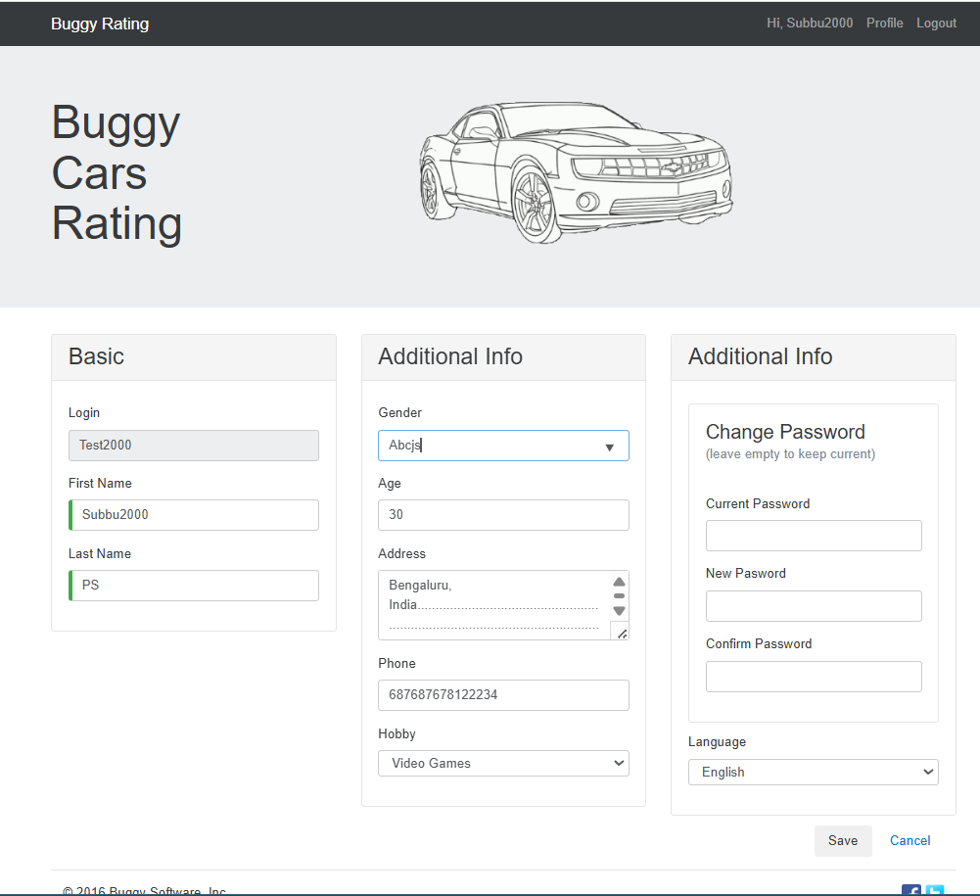- Shows Gender field with "Abcjs" entered
- No error indication

Screenshot 2: Successful Save with Invalid Data
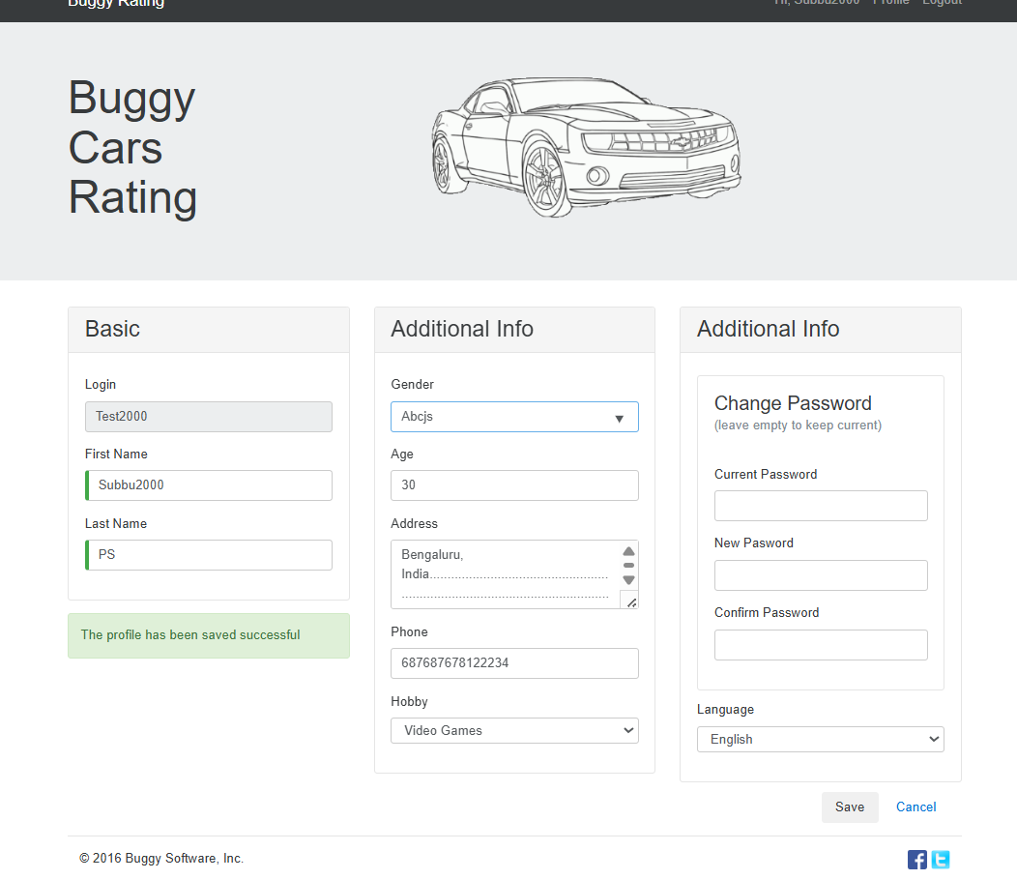- Shows success message: "The profile has been saved successfully"
- Invalid gender value saved

Screenshot 3: Invalid Data Persists After Refresh
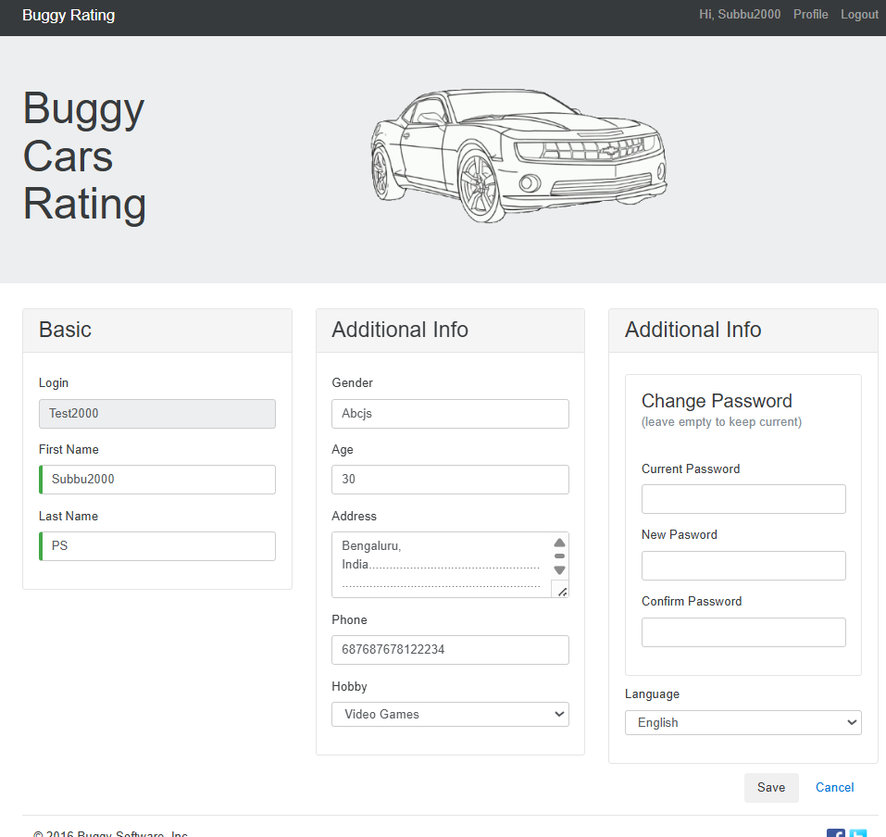- Shows Gender field still containing "Abcjs" after page refresh
- Confirms invalid data stored in database

Suggested Fix:
Workaround for Users:
NO acceptable workaround. Users should enter only valid gender options manually.

BUG-002: Phone Number Field Accepts Unlimited Digits Without Validation
Bug ID: BUG-003
Summary: Phone field lacks length validation and accepts excessive digits (15, 20, 50+ characters)
Severity: High
Priority: High
Status: Open
Bug Type: Functional - Data Validation, Input Validation
Bug Category: Data Integrity, User Experience
Environment:
- Browser: Google Chrome/ Firsfox
- OS: Windows 11
- URL: https://buggy.justtestit.org/profile
Description: The Phone Number field in the user profile "Additional Info" section has no length validation. Users can enter phone numbers with excessive digits (15, 20, 50, or even 100+ digits) without any error or restriction. The system accepts and saves invalid phone numbers, compromising data integrity and making contact information useless for actual communication purposes.
Steps to Reproduce:
- Login to application with valid credentials (Username: Subbu2000)
- Navigate to profile page (click "Profile" link)
- Scroll to "Additional Info" section
- Locate the "Phone" field (currently shows: 687687678122234)
- Clear the phone field
- Enter an excessively long phone number: "12345678901234567890123456789012345" (35 digits)
- Click "Save" button
- No validation error displayed
- Success message: "The profile has been saved successfully"
- Refresh the page
- Observe: Invalid 35-digit phone number is saved and displayed

Additional Test Cases:
- Enter 100+ digit number: Result: Accepted and saved
- Enter letters "abcdefgh": Result: Should be tested (likely accepts)
- Enter special characters "+91-1234567890": Result: Should allow country codes
- Enter 5 digits "12345": Result: Should reject (too short) but likely accepts
Expected Behaviour:
- Phone field should have minimum length validation (10 digits for most countries)
- Phone field should have maximum length validation (10-15 digits including country code)
- Phone field should only accept numeric characters (and optional + - () for formatting)
- Invalid length should trigger validation error:
"Phone number must be between 10-15 digits"
"Phone number is too short"
"Phone number is too long"
- Letters and excessive special characters should be rejected
- Form should NOT save with invalid phone number
- Real-time validation feedback as user types
Actual Behaviour:
- Phone field accepts UNLIMITED number of digits
- Tested with 35 digits: Accepted and saved
- NO minimum length check (can save 1-2 digits)
- NO maximum length check (can save 50, 100+ digits)
- NO character type validation (may accept letters - needs testing)
- NO format validation
- Form saves successfully regardless of length
- Success message: "The profile has been saved successfully"
- Invalid phone numbers stored permanently in database
Severity Level: High
Priority Level: High
Screenshots/Attachments:
Screenshot 1: Entering Excessive Digits
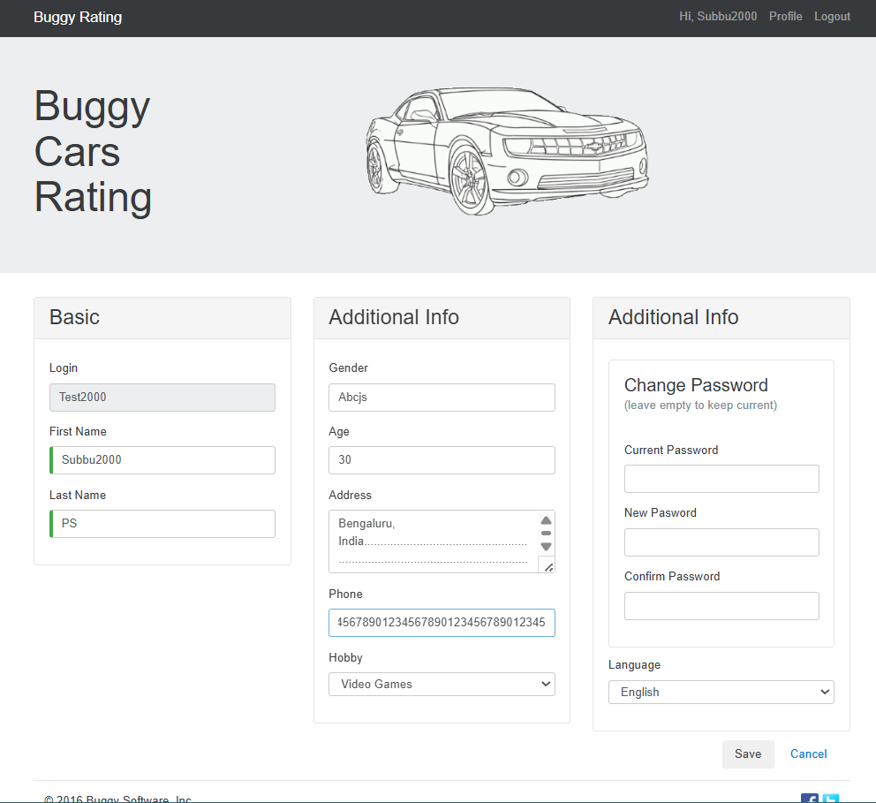- Shows Phone field with 35-digit number
- No error indication visible

Screenshot 2: Success Message with Invalid Data
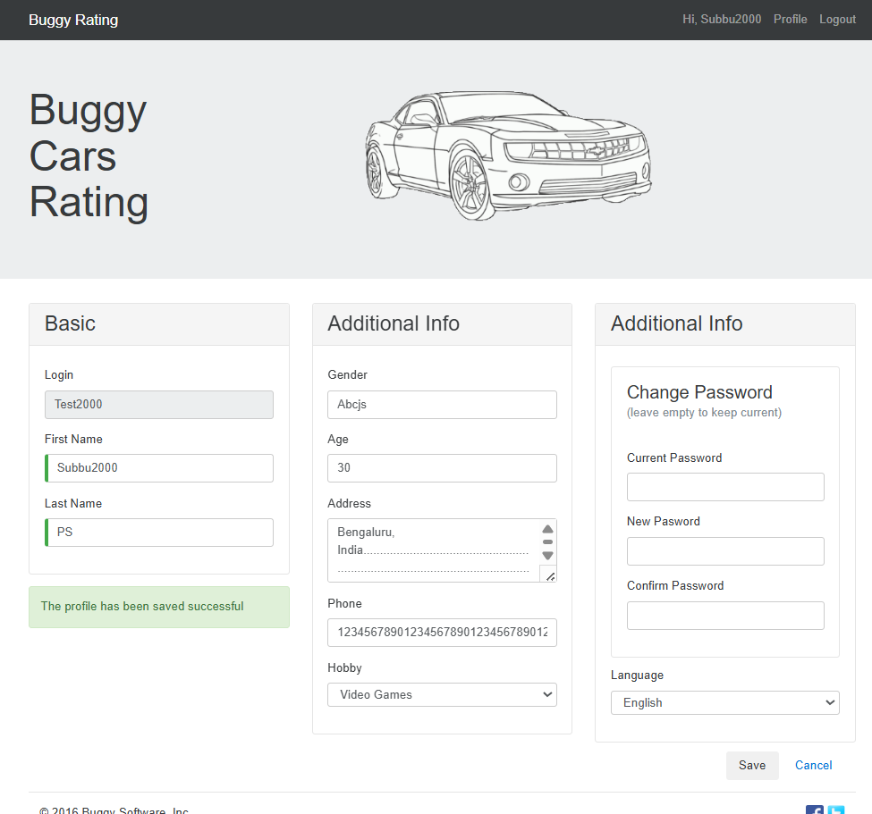- Success message displayed
- 35-digit phone number saved

Screenshot 3: Invalid Data Persists
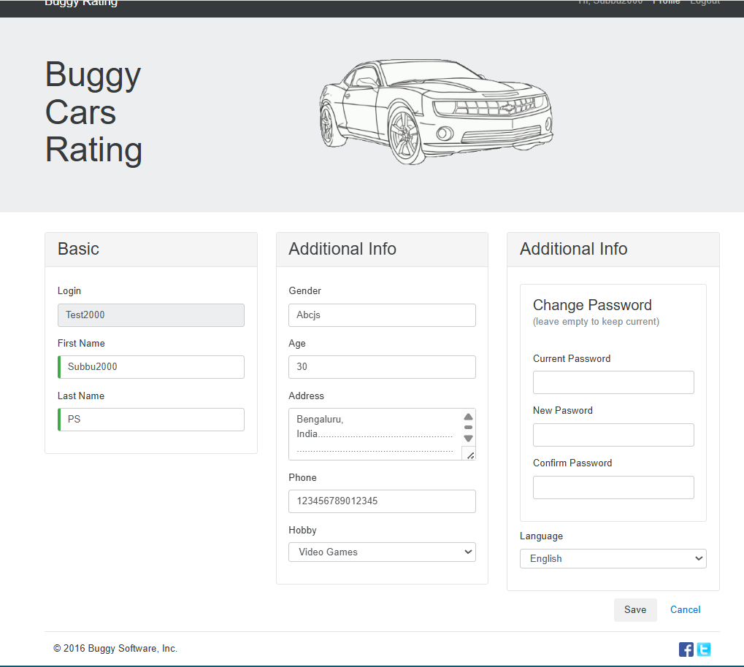- After refresh, 35-digit number still displayed
- Confirms storage of invalid data

Suggested Fix:
Workaround for Users:
- Manually enter only 10-digit phone numbers
- Do not enter more than 15 digits
- Follow format: + [country code] [10-digit number]
- NO system enforcement, relies on user discipline

BUG-003: Address Field Accepts Unlimited Characters Without Length Validation
Bug ID: BUG-003
Summary: Address field has no maximum length limit and accepts excessive text (500, 1000+ characters)
Severity: Medium
Priority: Medium
Status: Open
Bug Type: Functional - Data Validation, Input Validation
Bug Category: Data Integrity, User Experience, Potential Security
Environment:
- Browser: Google Chrome/ Firefox
- OS: Windows 11
- URL: https://buggy.justtestit.org/profile
Description: The Address field in the user profile "Additional Info" section lacks maximum length validation. Users can enter extremely long addresses (500, 1000, or even 10,000+ characters) without any restriction or error message. The system accepts and saves this excessive data, which can cause database storage issues, UI display problems, and potential security vulnerabilities (though SQL injection should be prevented at backend level).
Steps to Reproduce:
- Login to application (Username: Subbu2000)
- Navigate to profile page
- Scroll to "Additional Info" section
- Locate the "Address" text area field
- Clear existing address
- Enter an extremely long address (paste 500+ character text) Example: "123 Main Street, Apartment 4B, Building Complex Name... [repeat 50 times]"
- Click "Save" button
- Observe: No validation error displayed
- Observe: Success message appears
- Refresh page
- Observe: Entire 500+ character address is saved and displayed

Test Cases:
- Test 1: Enter 500 characters → Result: Accepted
- Test 2: Enter 1000 characters → Result: Accepted
- Test 3: Enter only special characters "@@##$%%^^" → Result: Likely accepted
Expected Behaviour:
- Address field should have reasonable maximum length (200-250 characters)
- Reasonable address format validation
- Special characters should be allowed (for addresses like "123 O'Brien St, Apt #4-B")
- But excessive special characters should raise warning
- SQL injection attempts should be sanitized/escaped
- Validation error should display:
"Address is too long (maximum 250 characters)"
"Please enter a valid address"
- Character counter showing remaining characters
- Form should NOT save address exceeding limit
Actual Behaviour:
- Address field accepts UNLIMITED characters (tested up to 500+)
- NO maximum length restriction
- NO format validation
- Accepts only special characters
- NO character counter
- NO user guidance on acceptable length
- Form saves successfully with any length address
- Success message: "The profile has been saved successfully"
- All data stored in database (may be truncated silently depending on DB column size)
Severity Level: Medium
Priority Level: Medium

Screenshots/Attachments:
Screenshot 1: Entering N number of Character Address
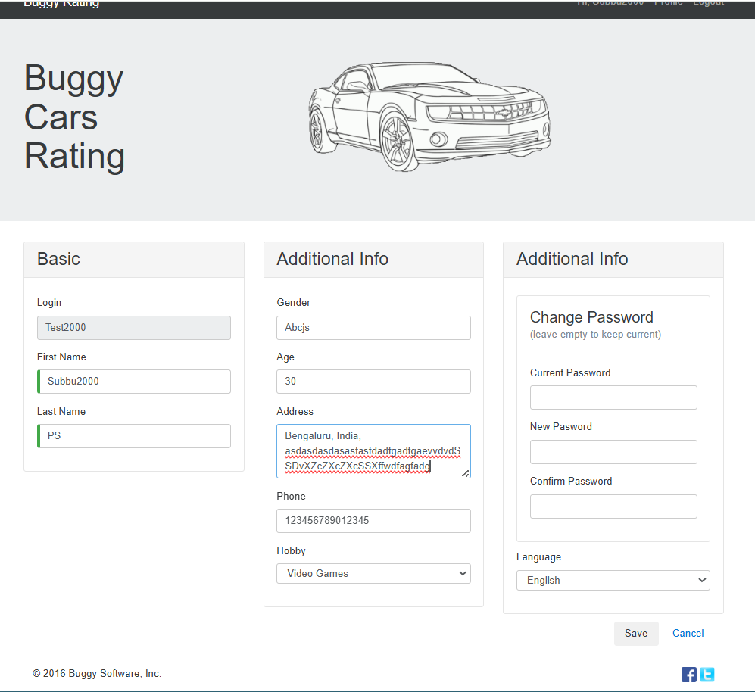- Shows Address text area filled with extremely long text
- No character limit indicator
- No error message

Screenshot 2: Success Message with Excessive Address
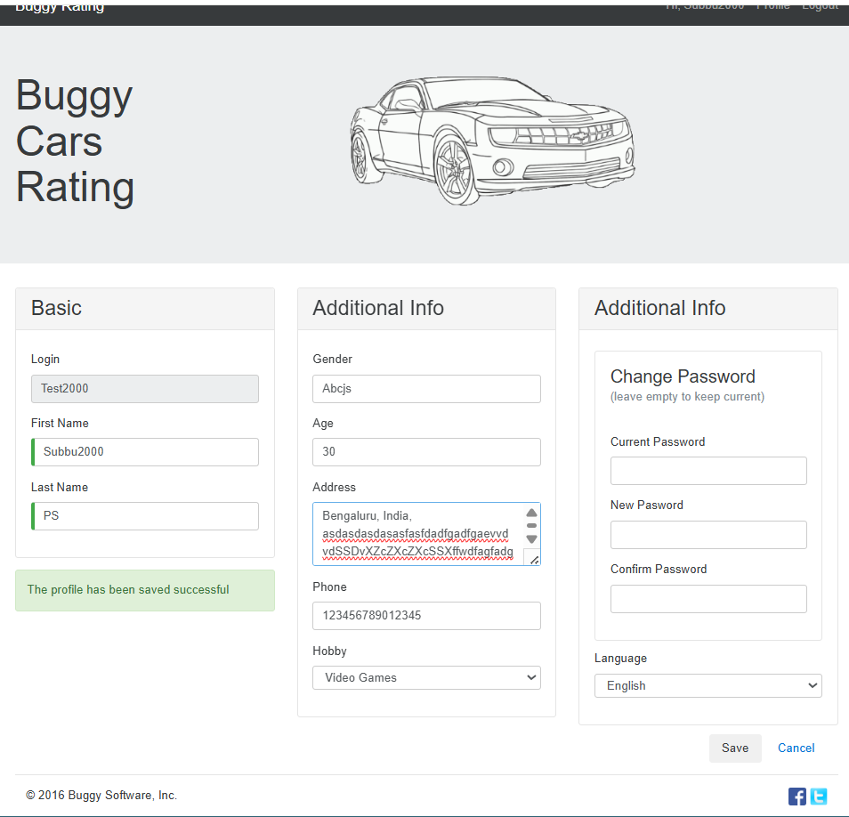- Success message displayed
- N number of character address saved
Suggested Fix:
Workaround for Users:
- Manually keep addresses under 200 characters
- Use abbreviations (St instead of Street, Apt instead of Apartment)
- NO system enforcement

BUG-004: Registration Form Accepts Empty Spaces in Name Fields
Bug ID: BUG-004
Summary: Registration form accepts whitespace/empty spaces as valid names - allows user creation with blank First Name and Last Name
Severity: High
Priority: High
Status: Open
Bug Type: Functional - Data Validation, Input Validation
Bug Category: User Experience, Input Validation, Data Integrity
Environment:
- Browser: Google Chrome/ Firefox
- OS: Windows 11
- URL: https://buggy.justtestit.org/profile
Description:
The registration form contains a critical validation flaw where it accepts whitespace characters (spaces, tabs) as valid input for the First Name and Last Name fields. When a user enters a valid username and password but fills the name fields with only spaces, the system successfully creates the account with blank names
Steps to Reproduce
Scenario 1: All Fields with Spaces (Works Correctly)
- Navigate to https://buggy.justtestit.org/
- Click "Register" button in header
- In "Login" field, enter spaces: " " (5 spaces)
- In "First Name" field, enter spaces: " "
- In "Last Name" field, enter spaces: " "
- In "Password" field, enter spaces: " "
- In "Confirm Password" field, enter spaces: " "
- Click "Register" button
Expected Behavior
(Before Submission):
- Form should trim whitespace from all fields
- After trimming, check if value is empty
- If empty after trimming:
Display error message: "First Name is required and cannot contain only spaces"
Highlight field with red border
Prevent form submission
- All fields should have real-time validation
Actual Behavior
- User enters username as "blank spaces "
- User enters 5 spaces in First Name field
- User enters 5 spaces in Last Name field
- User enters valid password: "Test@123"
- User clicks Register button
- User is able to Register successfully

Severity Level: High
Priority Level: High
Screenshots/Attachments:
Screenshot 1: Entering Blank spaces number of Character Address
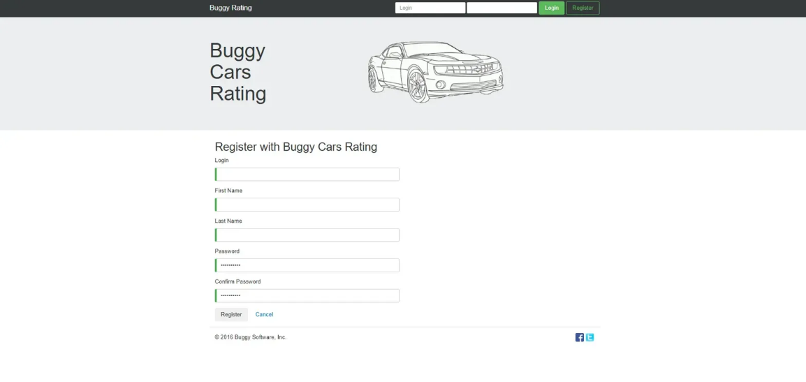
- Shows Login, First name, Last name text area filled with filled with blank spaces
- No error message

Screenshot 2: Success Message like Registration is successful is appearing
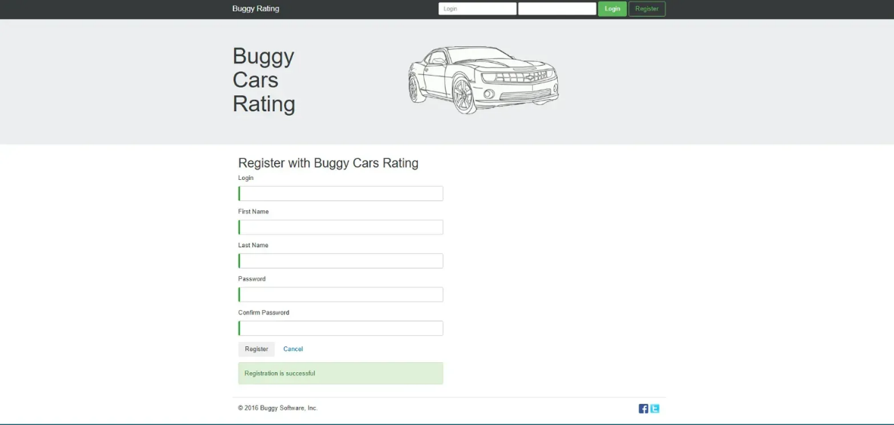
- Success message displayed
- Users with character blank spaces is saved

Suggested Fix
For Users (Workaround):
Users must:
- Enter valid first and last names during registration
- Avoid using only spaces in any field
- System should prevent this automatically

